2nd Grade Supply List
Dear parents/guardians,
Welcome to the 2nd grade! There are several items your child will need for this school year. We ask that you place all the supplies in a big bag with your child’s name and class written on the bag. Thank you so much for your help!
- 2nd Grade Teachers
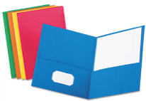
- 5 colored folders (red, green, yellow, purple, and blue – solid colors only,
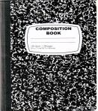
all folder should be plastic)

- 6 black and white composition notebooks
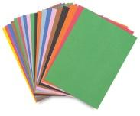
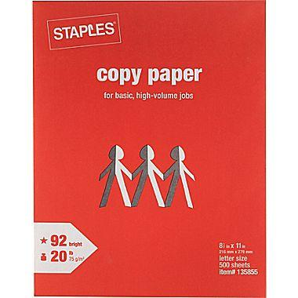
- 1 pack of construction paper

- 2 packs of white copy paper (8” x 11”, 500 pages)
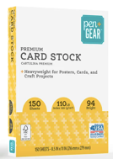

- 1 pack of cardstock paper

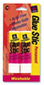
- 4 glue sticks

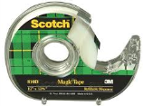
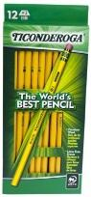
- 1 3M Scotch clear tape

- 2 boxes of 12 Ticonderoga pencils
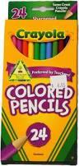

- 1 pack of 24 Crayola colored pencils
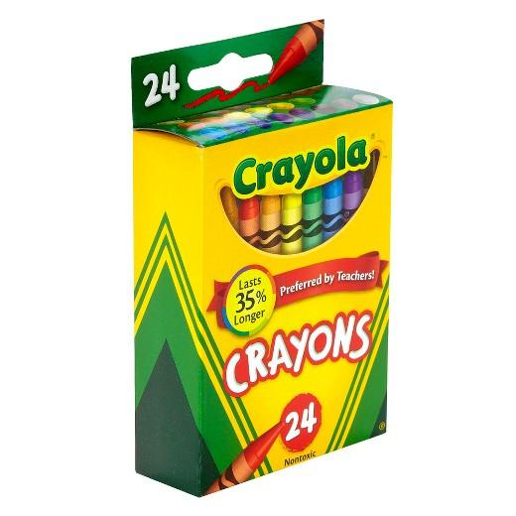

- 1 pack of 24 Crayola crayons

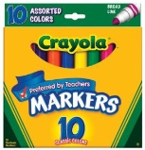
- 1 pack of 10 Crayola markers
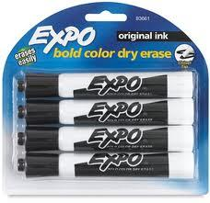
- 1 package of Expo dry-erase markers (black)
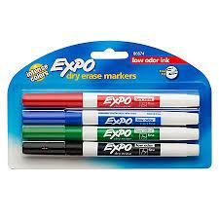
- 1 package of thin point Expo dry-erase markers
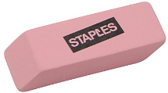
- 2 pencil erasers
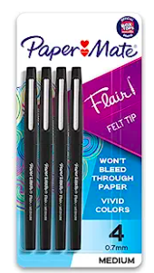
- 1 pack of flair pens
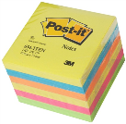

- 3 packs of 3M Post-its (4 inches by 4 inches)

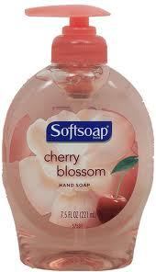
- 1 bottle of Softsoap hand soap

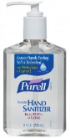
- 1 bottle of Purell hand sanitizer
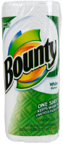

- 2 rolls of Bounty paper towels

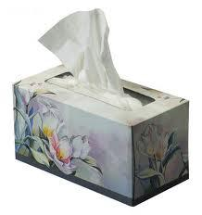
- 2 boxes of Kleenex tissues

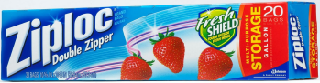
- 2 boxes of Ziploc gallon bags (storage bags)

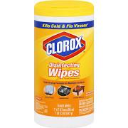
- 2 tub of Clorox Wipes
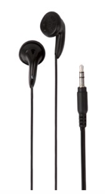
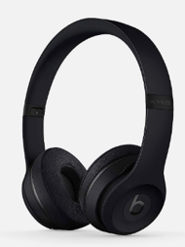

- 1 pair of headphones

